ENGSCI 9510 Engineering Planning & Project Management

Assignment #2 – Xinyu Yun

Q1. After the calculation of net present value in 5 years, the value is positive based on the estimated return rate and inflation rete. So the project should be invested.

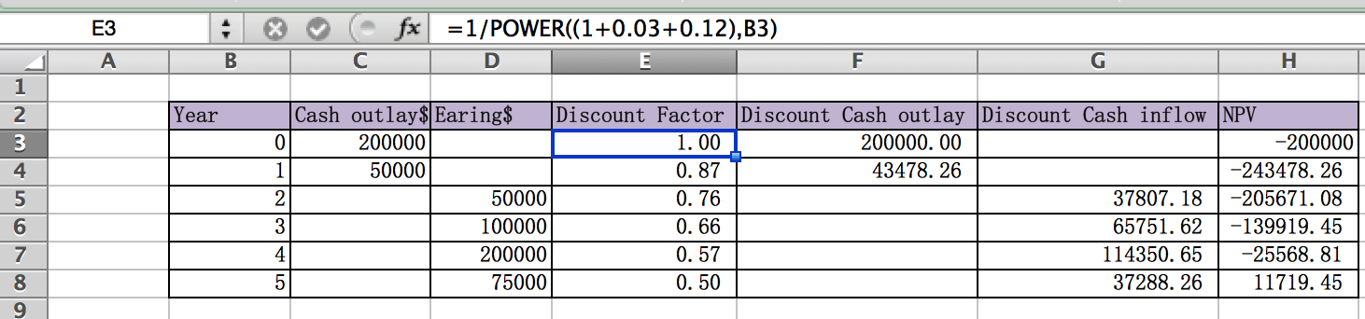

Q2.

1. Net present value calculation based on the rate of return 12% and inflation rate 4%:

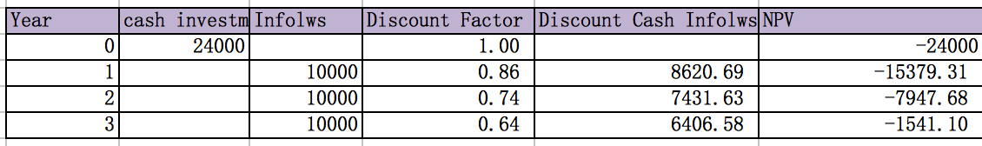

From the table we can see the NPV is negative after the fourth year, so the project is not worth funding.

1. If the company adjust the rate of return to 15%:

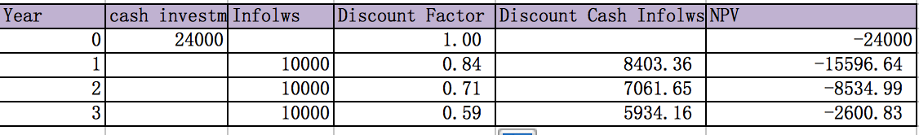

we will see the discount factor is lower than which has the 12% return rate, so the NPV is still negative, base on that the invest of this project is not worthy.

Q3.

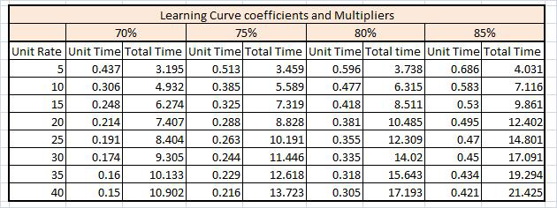

a. As shown from the learning curve table, the accordant unit time coefficient for 5th with assumed learn curve 80% is 0.596(C), the T1 (time needed to produce the 1st unit) is 100000 hours, and the labor rate(LR) is $35/hour.

So the expected payment for 5th unit is:

T1\*C\*LR = 100000\*0.596\*35 = $2086000

b. The total time coefficient for 5 units with assumed learn curve 80% is 3.738(TC).

So the duration of all 5 units is T1\*TC = 100000\*3.738 = 373800 hours